DATA:
1 John Doe 100 IT 60000.00 2020-01-15 john.doe@example.com
2 Jane Smith 100 HR 55000.00 2021-04-20 jane.smith@example.com
3 Alice Brown 101 IT 70000.00 2019-09-10 alice.brown@example.com
4 Bob Johnson 102 Finance 80000.00 2022-02-25 bob.johnson@example.com
5 Charlie White 100 Marketing 45000.00 2023-06-05 charlie.white@example.com
6 David Green 101 Engineering 75000.00 2018-03-10 david.green@example.com
7 Eva White 101 Engineering 78000.00 2019-06-22 eva.white@example.com
8 Frank Black 102 Finance 85000.00 2017-05-30 frank.black@example.com
9 Grace Blue 102 Finance 82000.00 2020-08-15 grace.blue@example.com
10 Henry Grey 103 Sales 60000.00 2021-01-10 henry.grey@example.com
11 Ivy Red 103 Sales 62000.00 2022-04-18 ivy.red@example.com
Mapping Screenshot:
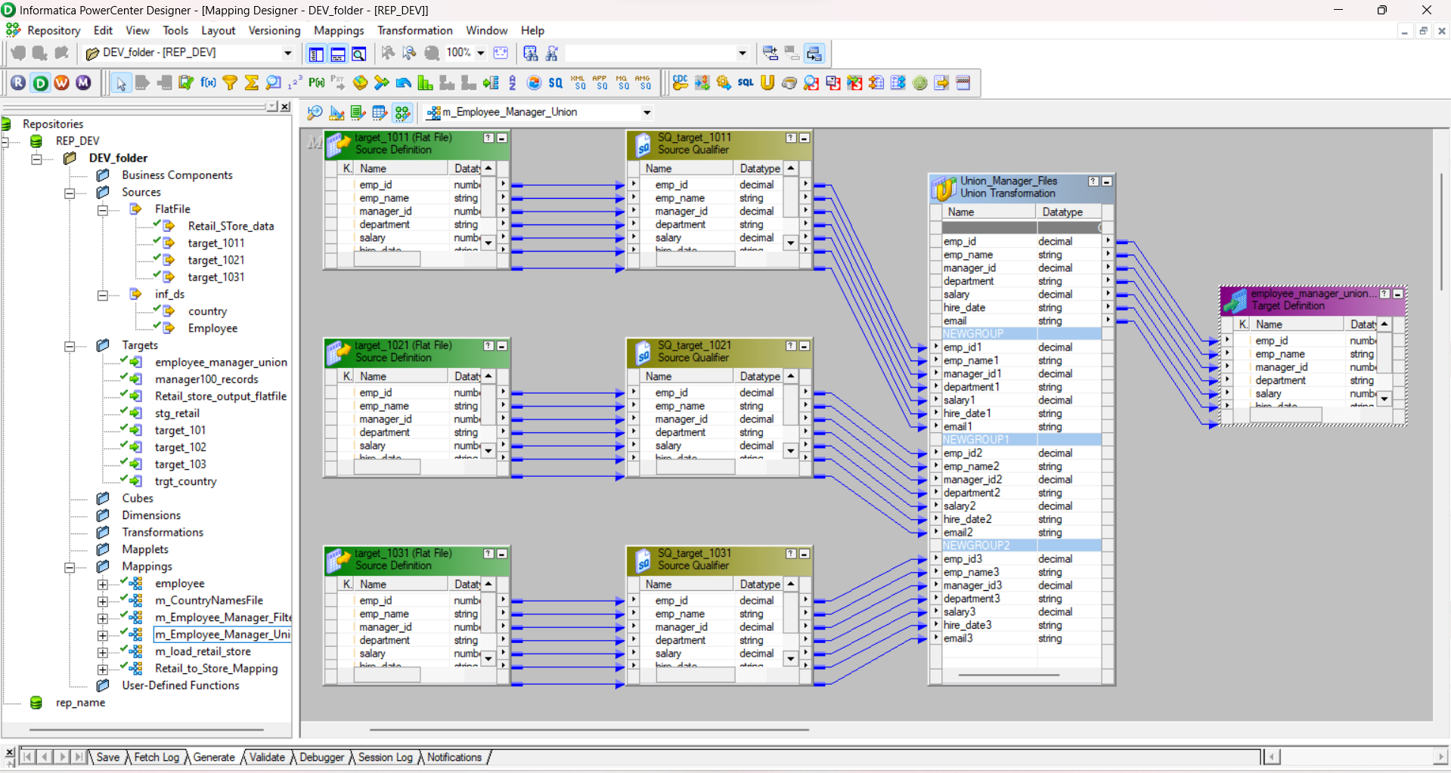

TOOK IMAGES OF THE SCREEN , SINCE THE MY SYSTEM HAD A PROBLEM WITH SCREENSHOTS

Workflow Manager screenshot: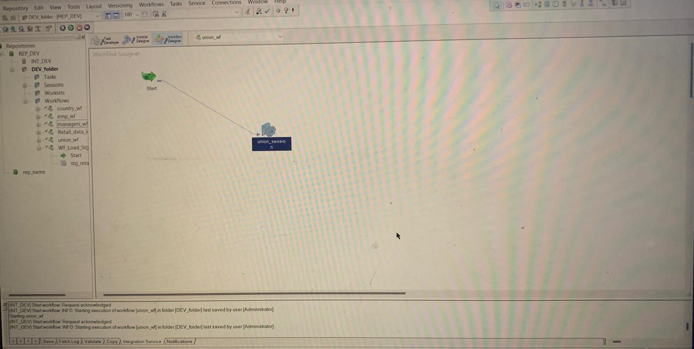

Workflow monitor screenshot:
